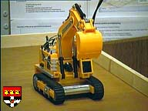

Digger User Manual – Assignment 1 and 2

Digger User Interface:

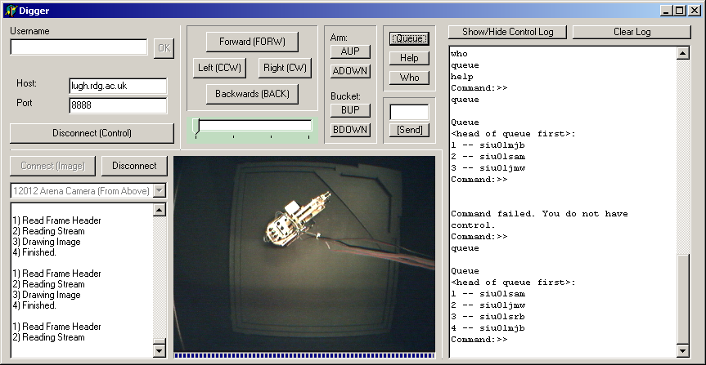

Stream Log
Video Stream Window
Control Log

Control Panel

Login Panel

Login:

Make sure the host and port of the server are correct. (In this case host=lugh.rdg.ac.uk and port=8888.)
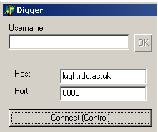

Click the ‘Connect (Control)’ button.

Once you have connected, the connect button will turn into a disconnect button.

When the server prompts you for a username, the top edit box will be enabled, and you will be able to type your username, pressing enter or clicking the OK button will send the username to the server.

When a password prompt is received the edit box toggles to a password box, and allows you to input your password.

If you are successful, the edit box will be disabled.

If you are unsuccessful then you will be presented with the following message box, stating that you were unsuccessful. The edit box will then toggle back to a username input box, to allow you to try again.

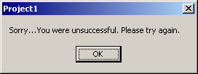

Once you have managed to connect to the server, you are either placed in a queue or (if no-one else is connected) gain control of the digger.

The following two message boxes respectively show this:

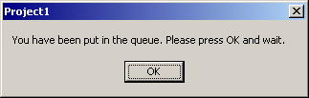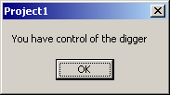

Digger Control:

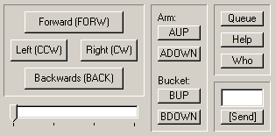

Once you have successfully logged in, and reached the front of the queue. You will want to move the digger. The Digger control panel accomplishes this.

The digger control panel allows you to send various commands, by clicking on the appropriate button. The forward, left, right and back buttons move the digger’s tracks. AUP and ADOWN move the digger’s arm. BUP and BDOWN move the digger’s bucket.
The queue command will show you the queue of people waiting for control of the digger. Custom messages can be sent by typing them into the edit box and then clicking the “[Send]” button.

The slider at the bottom left lets the user choose the magnitude of the movement, 1 to 4 (e.g. to get “back 3” move the slider to 3 and click the “back” button).

Diagnostics:

There is a memo box on the right of the form that will log all messages passing between client and server.

This log can be cleared by clicking the “Clear Log” button, or toggled between visible and invisible by clicking on the “Show/Hide Control Log” button.
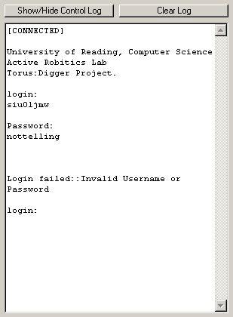

Visualization:

To start an image stream from the image server, first select a camera (Digger or Arena) from the drop-down list and then click the “Connect (Image)” button.

The progress bar under the image shows

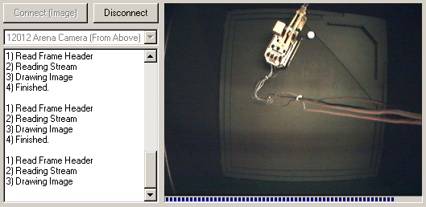

The image streamer is independent of the control part of the program. Images can be streamed whether or not you are logged into the control server. The image streamer runs within its own “higher” priority thread, to speed up display of the image and to stop the control panel from becoming slow or unresponsive.

To disconnect from the image server, click the “Disconnect” Button.

Computer vision.

Main Form

The main form has two components related to computer vision. These are shown below.

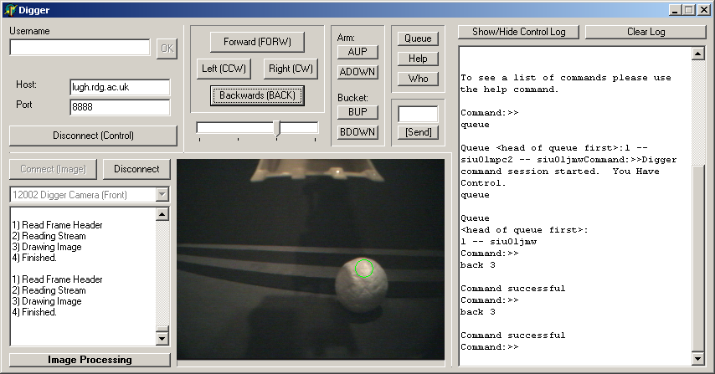

Green circle indicating ball’s position

Button to show image processing form

Every time a frame is received the ball’s position is be calculated and displayed by a green circle on the main form. The position and size of this circle is calculated by performing thresholding on a filtered greyscale image. The original image (from the camera) is converted to greyscale and filtered as flows:

col:=((r+g+b)div 3);
col:=col-(ImgProcessing.DivTrackBar1.position*(((r+g)div 2)-b));

The filtering helps to remove predominately yellow items (such as the digger arm) from the image, thus making it easier for a more accurate match to be made by using a threshold.

Image Processing Form

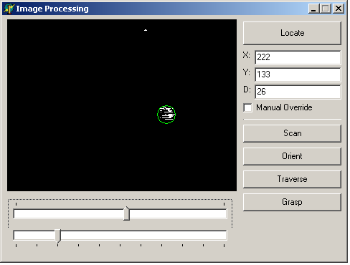
Green circle around the area the ball is calculated to be.
This image shows the original camera view after a yellow pass filter and thresholding has been applied.

Greyscale Threshold

Multiplier for the yellow pass filter (to help remove the digger arm).

Textboxes to hold internal position of ball
(Use “Manual Override” to stop automatic ball location detection)

Various command that can be run when connected to the control server.
These are: Locate, Scan, Orient, Traverse and Grasp.

Intelligent Control

When the locate button is pressed, the program will search the image for the presence of a ball. If found, the ball’s central co-ordinates and diameter are written into the text boxes on the image processing form. If the ball is not found a message box is shown stating “No Ball Found”
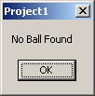

When every frame is received the image is searched for the location of the ball, drawing a green circle round the ball, though if the ball is not found in the automatic cycle then the circle is not displayed and no message box is raised.

When the “Scan” button is pressed the digger will rotate until a ball is found, if after 20 x (ccw 4) rotations the ball is still not found then the function will finish. If the ball is found, its co-ordinates are returned to the textboxes on the Image Processing form.

On pressing the “Orient” button, the digger will try to orient itself with the ball.

When the “Traverse” button is pressed, the digger will move forward in steps of fw 1 and once the ball is within the grasp zone the digger will stop.

The final button is “Grasp”, when this is clicked the digger will do all of the above. Namely, scan for the ball, orient to it, move toward it, and then pick it up in the scoop.

Manual Control

If the ball is incorrectly placed or not detected, it is possible to override the system to specify a ball position manually.
This is done by dragging a rectangle over the camera image.
You must click the “Manual Override” checkbox if you do not wish the system to recalculate the ball’s position.

When Manual override is selected the Scan, Orient, Traverse and grasp functions will all use the user defined ball position, and not recalculate it.

